MEMBERS PRESENT:  Mr. Scott Bachmann, Chair  Mr. Justin Verst  Mr. John Fessler, TPO  Ms. Susan Meyers | STAFF PRESENT:  Mr. Kirk Hunter, Principal Planner  Mr. Michael Duncan, Legal Counsel
MEMBERS ABSENT:  Mr. Roger Mason, Vice Chair  Mr. Joseph Williams  Mr. Michael Williams | STAFF ABSENT:  Ms. Cynthia Minter, Director
Mr. Bachmann called the meeting to order at 7:00 PM with the Pledge of Allegiance. Following roll call, a quorum was found to be present. Mr. Bachmann continued the meeting by asking if everyone had read the November, 2018 meeting minutes and if there were any questions or corrections. There being no comments or corrections, Mr. Bachmann called for a motion to approve the minutes. Mr. Fessler made a motion to approve the minutes as submitted. Mr.Verst seconded the motion. Mr. Bachmann called for a roll call vote. A roll call vote found Mr. Bachmann, Mr.Verst and Mr. Fessler in favor. Ms. Meyers abstained as she was not present for the November 2018 meeting. The motion passed.

Mr. Bachmann introduced case BA-18-017 for Mr. Brooks Parker at 9338 Echo Hills, Unincorporated Campbell County, KY requesting a front yard setback variance. Mr. Hunter proceeded with the staff report.

Considerations:

The applicant is requesting a setback variance. His intention is to construct a new single-family house. The soil conditions and topography of the lot limit the area suitable for a septic system. The ideal position of the septic system requires the house to be positioned closer to the front property line, encroaching on the minimum front yard setback.

- The site, containing approximately 1.0 acre, is located in Unincorporated Campbell County on Echo Hills, a County-maintained road. This site is located in the Residential Rural Estate Zone within a phased zoning overlay: R-RE (P). The Recommended Land Use Map of the 2008 Campbell County Comprehensive Plan identifies the site and surrounding areas as urban mixed-use. The phased (P) zoning overlay is in place in anticipation of increased density in the future as indicated in the Comprehensive Plan. See Section 9.26 of the Zoning Ordinance for more information on phased zoning.
- Currently, the surrounding land is zoned R-RE (P) to the north, west and south comprised of single-family residential land uses. To the east the area is zoned RC Rural Commercial and is comprised of commercial uses.

- The Campbell County Zoning Ordinance Article X, Section 10.2 classifies the area within the R-RE Residential Rural Estate Zone. Permitted uses within this zone include:

1. Single family dwellings, detached.
2. Horse related uses, including riding and boarding stables for personal use with minimum lot area of 4 acres provided that the location for a detached single-family dwelling has been sited meeting all applicable area and height regulations for all structures.
3. Greenhouse, nurseries or gazebo for personal use with minimum lot area of 4 acres provided that the location for a detached single-family dwelling has been sited meeting all applicable area and height regulations for all structures.

- The minimum setbacks for the R-RE zone are:

Description: | R-RE Zone  Regulations Require: | Applicant’s Request:
Minimum Lot Area: | One (1) acre
Minimum Lot Width: | One hundred (100) feet
Minimum Front Yard Depth: | Fifty (50) feet | Thirty (30) Feet
Minimum Side Yard Width: | Total - Twenty-five (25) feet
 | One side – ten (10) feet
Minimum Rear Yard Depth: | Thirty five (35) feet
Maximum Building Height: | Thirty five (35) feet
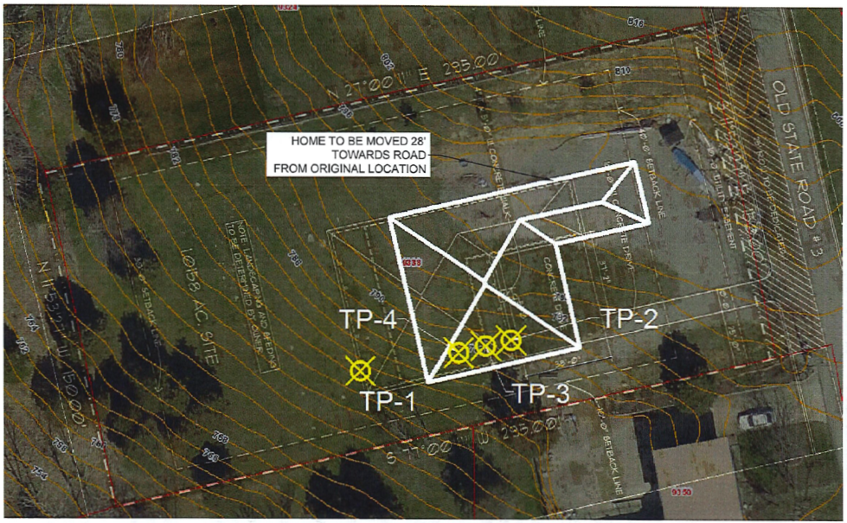
Figure 1: Site Plan Showing Test Locations

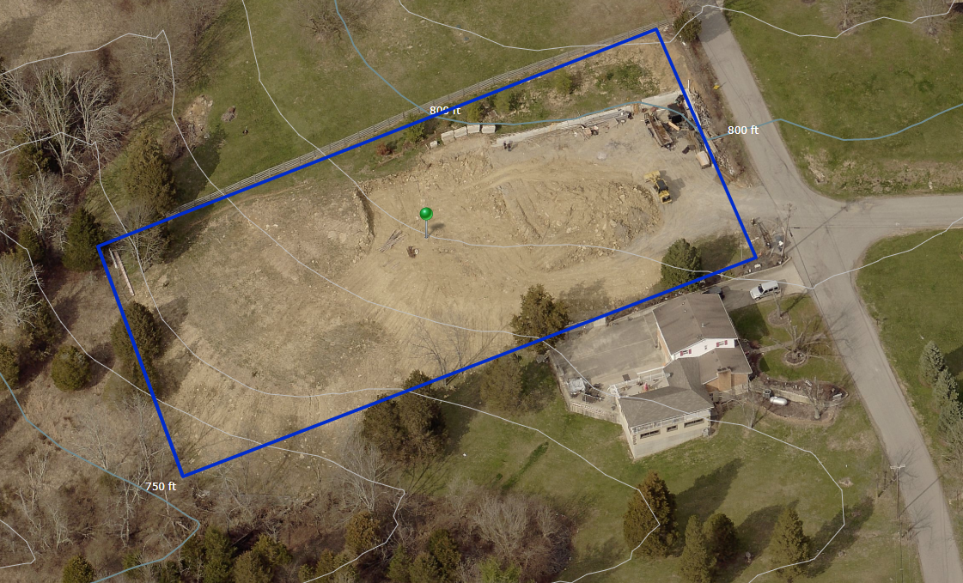
Figure 2: Oblique Aerial Showing Topography
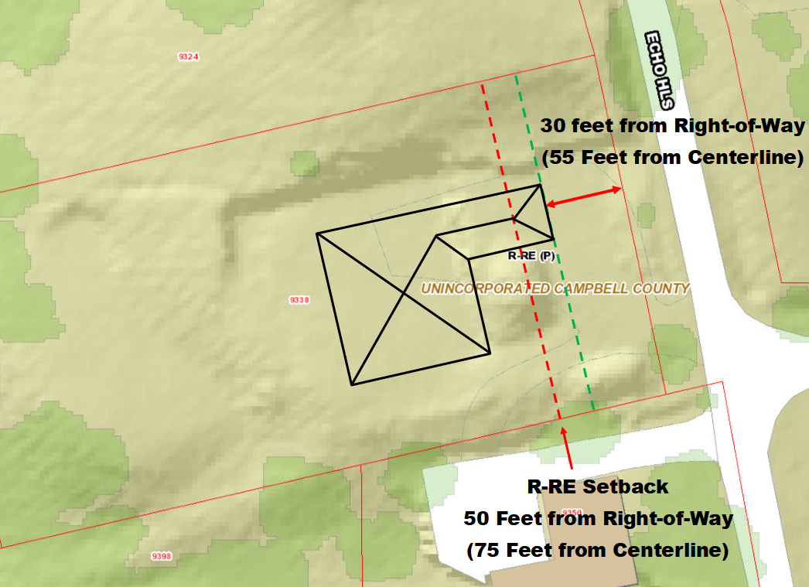
Figure 3: Proposed Site Plan

- A review of public records indicates the following:
  - No previous requests for a variance have been submitted for this site.
  - The applicant owns 9338 Echo Hills.
  - The dedicated public right-of-way on this parcel is twenty-five (25) feet from the centerline of Echo Hills.
  - Echo Hills is a County-maintained road that is sixteen (16) feet in width.
  - Many of the houses on Echo Hills do not meet the minimum front yard setback distance. The average setback distance for properties within three-hundred (300) feet on the same side of the street is approximately thirty-five (35) feet from the right-of-way.
  - A building permit was issued for this site in December 2017.
  - The original plan sited the house within the required setback distances.
- Per Section 18.6, A., 2., Notice: Notice of public hearing was given in accordance with Section 18.2 of the Campbell County Zoning Ordinance. A legal notice appears in the January 3, 2019 edition of the Campbell County Recorder advertising applicant’s request and the hearing to be held on January 15, 2019.

- According to Section 18.6, A., 4., the Board of Adjustment must find that the granting of the variance will be in harmony with the general purpose and intent of the Ordinance as well as the adopted Comprehensive Plan, and will not be injurious to the neighborhood, or otherwise, detrimental to the public welfare. The use of the property is consistent with the adopted 2008 Comprehensive Plan.

Supporting Information

VARIANCES: Before any variance is granted, the Board of Adjustment must find that the granting of the variance will not adversely affect the public health, safety, or welfare, will not alter the essential character of the general vicinity, will not cause a hazard or nuisance to the public. Such variance shall not be granted by the Board of Adjustment unless and until:

- That the requested variance arises from special existing circumstances which do not generally apply to land in the general vicinity.

- That the manner in which the strict application of the provisions of the Zoning Ordinance would deprive the applicant of a reasonable use of the land or would create an unnecessary hardship on the applicant
- That the circumstances are the result of actions of the applicant taken subsequent to the adoption of the zoning regulation from which relief is sought.
- Reasons that the variance will not allow unreasonable circumstance of the requirements of the zoning regulations and will not alter the essential character of the neighborhood.
- That granting the variance requested will not confer on the applicant any special privilege that is not conferred by this ordinance to other lands, structures or buildings in the same zone.

Applicants Comments:
“The lot 9338 Echo Hills adjacent to my current residence was purchased in 1996 and property deed did not show any set-backs, but only a 25’-0” ft. dedicated right-away. Upon issuing of the permit and site/roof plan in 2017, a 25’-0” right-away plus a 10’-0” utility easement and a 40’-0” setback line totaling 75’-0” ft. from center of road was given. Because of the soil (Silty Clay) and topographical conditions (property drops into a valley), a license professional engineer, Civil Solutions Associates (CSA) was contacted by me at the request of the building inspector before placement of footings could be approved. The deep house foundation footings took over 90 yards of 4000lbs concrete to reach embedment into the required shale. CSA’s findings after test pits were performed recommended moving the home to the East towards the road 28’-0” ft. thus causing the request of an encroachment of 20”-0” ft. into the 75’-0” setback.”
“If the strict application of the current ordinance is followed it will require shorting (reducing length) of the house and would decrease the value of the property and would cause an essential character of the neighborhood to change and lower the property value. In order to build on this site I had to bring in 300 yds. topsoil for approval of the septic system which also caused the west elevation of the property to raise over 10’-0” ft. and push the home further to the east setback.”
“Prior to the adoption of this zoning regulation there wouldn’t be a strict setback regulation (purchased property in 1996) that wouldn’t allow the home to be constructed without this variance. This is evident by the number of other existing homes in the area that do not have this requirement. The decision to move the home was due to soil conditions and recommendations from a licensed professional engineer along with topographical conditions. Most, if not all, land in the Campbell County rural area and in my general vicinity is quite hilly and uneven.
“Allowing a setback of 55’-0” from centerline of road along this area of Echo Hills is not unreasonable due to the sites (bad silty clay) soil conditions and topographical condition (land is in a valley area). The house would be within the current norm of this area and placing it nearer to the roadway poses no risk of right of way, safety of the roadway, blocking of utilities, or aesthetics of the immediate area and would add to the property value to the other residents on this street and neighborhood.”
“I understand that my home must conform to the requested variance and that building the home as submitted for permit is limited to granting the variance. Also any other structures requested would require additional variances and other homes in the area don’t influence this, or future variances requests.”

~Submitted December 12, 2018

Staff Comments:
The requested variance does arise from special circumstances, related to topography, which exist and do not generally apply to land in the general vicinity or in the same zone.

The application of the provisions of this Ordinance would create unnecessary hardship on the applicant.

The applicant is requesting this variance subsequent to the approval of these regulations.

The essential character of the neighborhood is agricultural and this action is compatible with agricultural use.

Mr. Hunter noted that the character of the neighborhood was in fact residential, and that indication in the staff report that it was agricultural was a mistake.

This variance would not be granting the applicant a special privilege.

Further Comments:
Some grading activity has already begun on the site. Staff requested the applicant discuss the progress so far and the measures taken to control erosion and sediment. Here is a response from Mr. Parker:
The Parker House 9338 Echo Hills
Erosion sediment control
Project Description
The purpose of the project is to construct a residential house. Approximately 3/4 acres will be disturbed during this construction period. The site is located in Campbell County, off US 27 at 9338 Echo, Hills Alexandria KY. (See Report of Geotechnical Study 9338 Echo Hills 03-15-18) I am the property owner of the existing home to the South.
Site Description
The site is rolling topography with slopes from North East of property at elevation 814 to South West of property at elevation 758 as it slopes into valley. On the northwest area there is a guttered vegetated grass lined channel that runs to the west wooded area. At the west end of the property 900 yds. of Top Soil was required for approval of septic leach lines and was placed in 2017 with the approval of the health department and has since started to have Vegetation growth. There is no evidence of erosion under present site conditions.
Adjacent Property
I am the property owner of the existing home to the south. To the north of the property is a residential home which is about 10’-0”ft to 15’-0”ft higher than existing property. Land used in the vicinity is residential. The land immediately to the west is heavily wooded, primarily in volunteer pine and undeveloped as it slopes into the valley. Sediment control measures have been taken to prevent damage and runoff into the valley and has since started vegetation growth.
Soils
The soil in the project area is mapped as silty clay loam in B and C slope classes. (See Report of Geotechnical Study 9338 Echo Hills 03-15-18)

Temporary gravel/concrete construction entrance/exit
A concrete/gravel construction entrance has been installed at the southeast corner of the property. During wet weather it may be necessary to wash vehicle tires at this location. The entrance will be graded so that runoff water will be directed to the southwest toward the valley. There has been no need for temporary diversions or sediment fence materials at this time as vegetation has begun from the March start date of deep foundation excavation.
Cut slopes
Will be fine graded immediately after rough grading; the surface will be disked and vegetated to allow vegetated slopes to be mowed, plantings will be protected with mulch.
***A minimum 15-ft undisturbed buffer zone will be maintained at the north perimeter of the disturbed area building site. (Neighboring house)
Stabilization of the remaining surfaces will be accomplished with vegetation and mulch. Dust control is not expected to be a problem due to the small area of exposure, and the relatively time of exposure. Should excessive dust be generated, it will be controlled by sprinkling.
Summary of Applicants Request:

The applicant is requesting a twenty (20) foot front yard variance due to soil and topographical conditions for the construction of a single-family house and reducing the fifty (50) foot setback to approximately thirty (30) feet.

Staff Recommendation:

To approve the applicant’s request for a front yard variance of twenty (20) feet for a new single-family house.

Basis for Recommendation

- In accordance with Section 18.2 of the Campbell county Zoning Ordinance, notice of public hearing was given in the January 3, 2018 edition of the Campbell County Recorder.

- In accordance with KRS 100.241 Variances, the board shall have the power to hear and decide on applications for variances. The board may impose any reasonable conditions or restrictions on any variance it decides to grant.

- The evidence presented by the applicant and staff is such as to make a finding that:

  - The requirements for a variance have been met by the applicant for a variance and the variance is the minimum variance that will make possible the reasonable use of the land, building, or structure.

  - The variance requested will not adversely affect the public health, safety, or welfare, will not adversely alter the essential character of the general vicinity, and will not cause a hazard or nuisance to the public and will not allow an unreasonable circumvention of the requirements of the zoning regulations. In making these findings, the board considered whether:

    - The requested variance arises from special circumstances which do not generally apply to land in the general vicinity, or in the same zone;

    - The strict application of the provisions of the regulation would deprive the applicant of the reasonable use of the land or would create an unnecessary hardship on the applicant; and

    - The circumstances are the result of actions of the applicant taken subsequent to the adoption of the zoning regulation from which relief is sought.

    - The variance will not allow unreasonable circumstance of the requirements of the zoning regulations and will not alter the essential character of the neighborhood.

    - The variance requested will not confer on the applicant any special privilege that is not conferred by this ordinance to other lands, structures or buildings in the same zone.

Mr. Hunter then turned discussion over to the board.
At this time Mr. Verst inquired about the type of lot adjacent to the property. To which Mr. Hunter replied with clarifications. Mr. Verst then verified that the neighborhood referenced does not have on street parking.

As there were no additional questions Mr. Bachmann gave the floor to Mr. Brooks for any additional comments. Mr. Brooks gave a brief history of the property, his reasons for building a home on the property and his construction efforts thus far.

Mr. Verst then inquired about specific details of the construction thus far, to which Mr. Brooks responded accordingly.

There were no additional members of the community in attendance who may have had comment or concern, so at this time the matter was turned over to the board. Mr. Bachmann asked the board if they had any additional comments or concerns. No concern was raised, so Mr.Verst made a motion to approve the requested front yard setback variance, on the basis of the information in the staff report and supporting evidence and testimony. Mr. Fessler seconded the motion.

A roll call vote found that Mr.Fessler, Ms. Meyers, Mr.Verst and Mr. Bachmann were all in favor. Mr. Bachmann then announced that the motion had passed and the request was approved.

Director’s Report:

Mr. Bachmann asked if there was a Director’s Report for this evening. As Ms. Minter was not present, no Director’s Report was submitted.

Mr. Hunter added that at this time there were currently no cases for February.

Election of officers was discussed, however with several members missing, it was decided to do this at another time. Mr.Verst requested that Mr. Bachmann or Ms. Minter reach out to members via e-mail to inquire about interest in elected positions going forward.

Mr. Bachmann asked if there were any other comments, questions or points for discussion among the Board. There being none, Mr. Bachmann called for a motion to adjourn. Mr. Fessler made a motion to adjourn. Mr. Verst seconded the motion. Mr. Bachmann called for an oral vote. An oral vote found all in favor of the motion. No one abstained. Motion passed.

The meeting adjourned at 7:21.

Prepared by: Approved:

_____________________________ ____________________________
Cindy Minter Scott Bachmann
Director Chair

